**The Ark Documentation.**

**Study Details (Creating a new Study).**

Log in and click the new button.

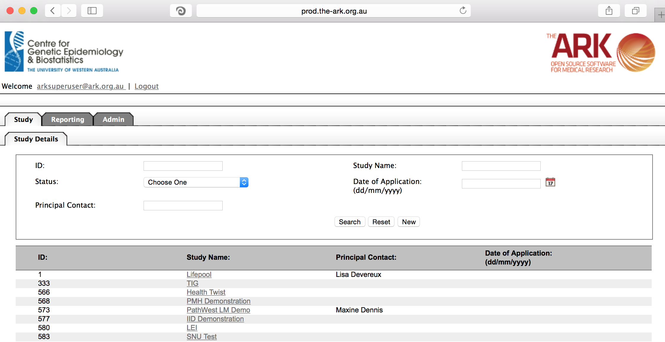

Alternatively if you have a very long list of studies under your management you may use the search pallette/panel at the top of the page. You can search/filter by id, name, principal contact, status of the study or date of application, just to make sure the study name does NOT already exist.

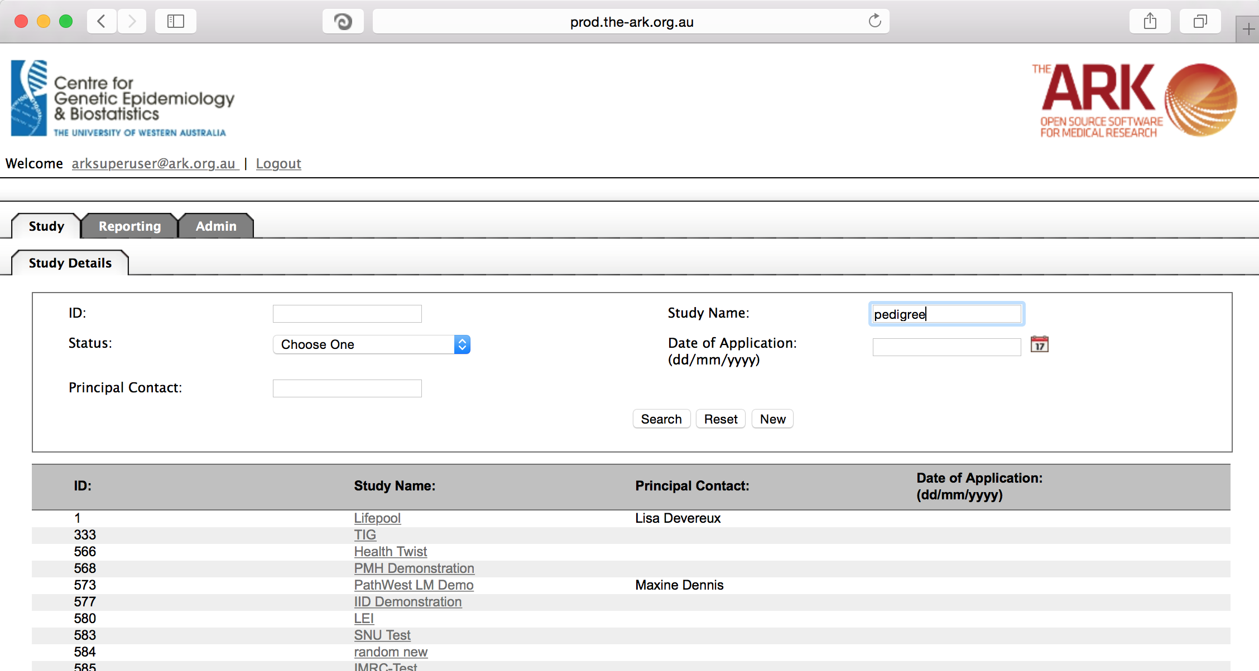

As you can see all fields are blank (but if you had any fields in your search previously, these will be brought across to this page for your convenience).

The only compulsory fields are Study name, status and Chief investigator. At a minimum you will also have study and subject modules selected.

Other useful modules for any research project are likely to be the;

* LIMS module (Laboratory Information Management System module). This is necessary for all specimen tracking and inventory.
* Reporting module for pre-made reports and customizable data extractions.
* Data sets module for recording longitudinal data / questionaires, which can be associated with subjects.
* Disease module and work tracking modules are new works in progress that will be expanded upon in future documentation.

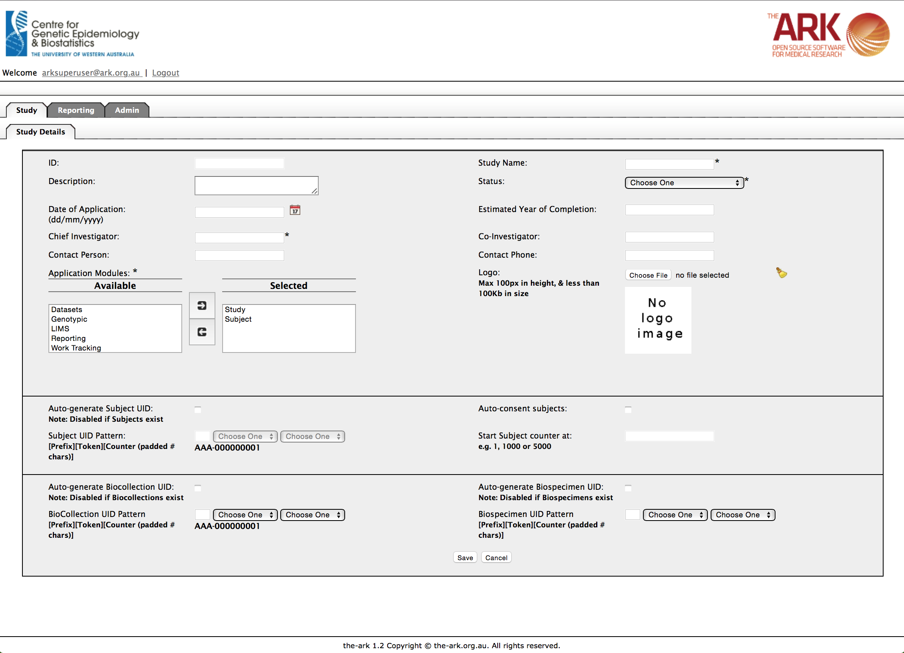

The available fields are all self-explanatory and you are welcome to use them as you see fit but I will list the following dangerous fields that have consequences beyond just being information. You will only be able to edit these fields if you have study administrator privileges.

* Study Name. Once you have decided a study name you are best to stick to it. There are certain bugs in the code, which will be fixed in future releases, where there are adverse affects from changing names. Trust us; don’t change names for now please.
* The status drop down is critical, as select an archived status could hide your study from searches and require and SQL adjustment to make it visible again (in the future a function may be added to recover studies).
* Application modules. You will only be able to use those modules that are selected here.
* Auto-generation of subject UIDs, Biospecimen UIDs, Biocollection UIDs. Once you have made these choices and utilized them in create of subjects/biospecimens, you are stuck with those fields permanently. Carefully consider if you want these auto-generated or not. This functionality has been made to prevent issues with duplicate identifiers.

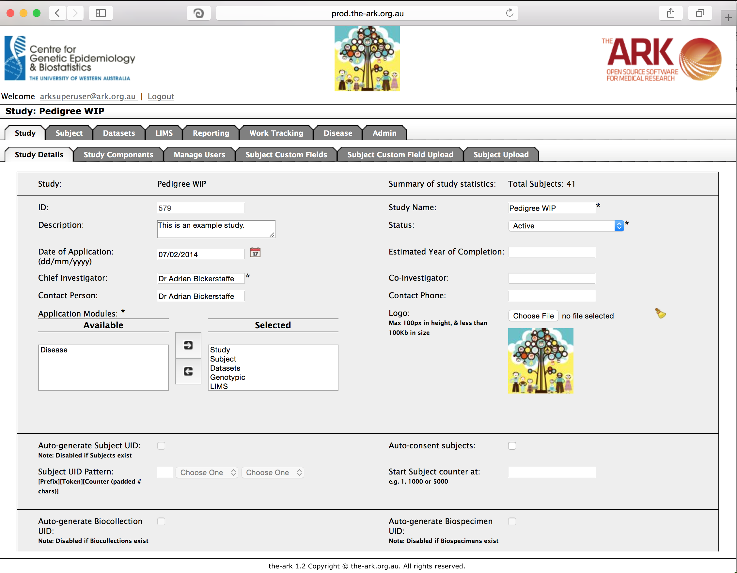

If you have no issues and it has correctly saved, the you will have a green message at the top of the page telling you so. If there were any issues (rare on this page), a message will show up in red describing what you have done wrong (eg; missing fields or incorrectly formed data).

